eCampus Download and Import Instructions
The course materials are stored in a Common Cartridge format which can be uploaded to most Learning Management Systems (LMSs) to create a fully organized course.

Download and Unzip the file
- Begin by downloading the .imscc package from eCampus Ontario:
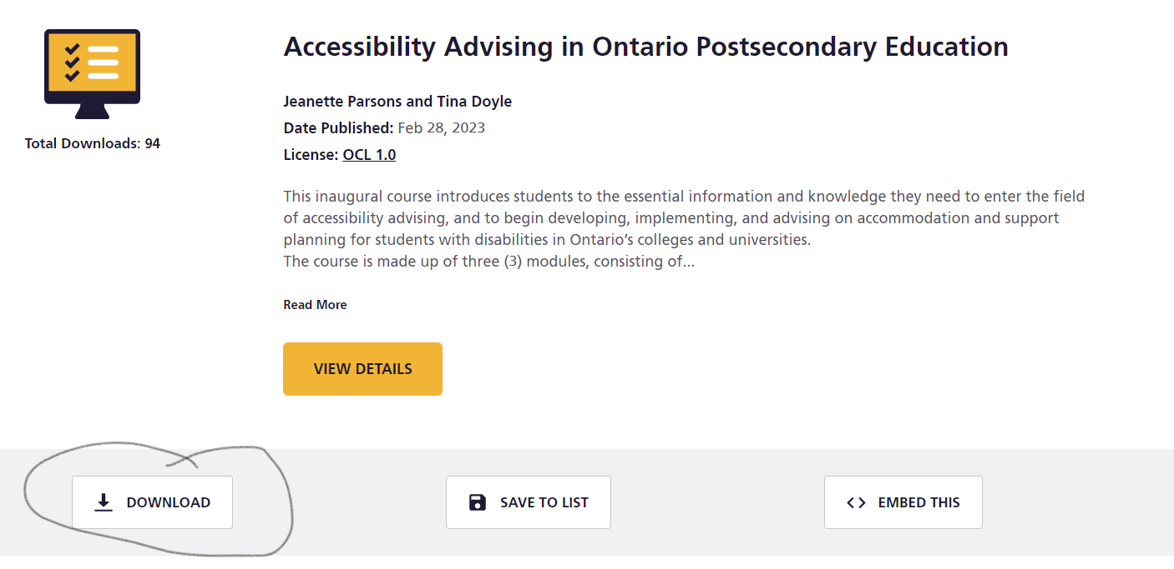
This will download a zip file to your Downloads folder.
- Once it’s downloaded, you’ll need extract the .imscc file from the zip folder. This is the file you’ll import into your LMS. Use your computer’s extraction/unzip tool to do this.

Import the file into your LMS
1. Navigate to a blank course shell within your LMS (NOTE: you may have to ask your LMS administrators to create a course for you).

In D2L BrightSpace:
- Click on ‘Edit Course’ in your navigation bar and navigate to “Import/Export/Copy Components”
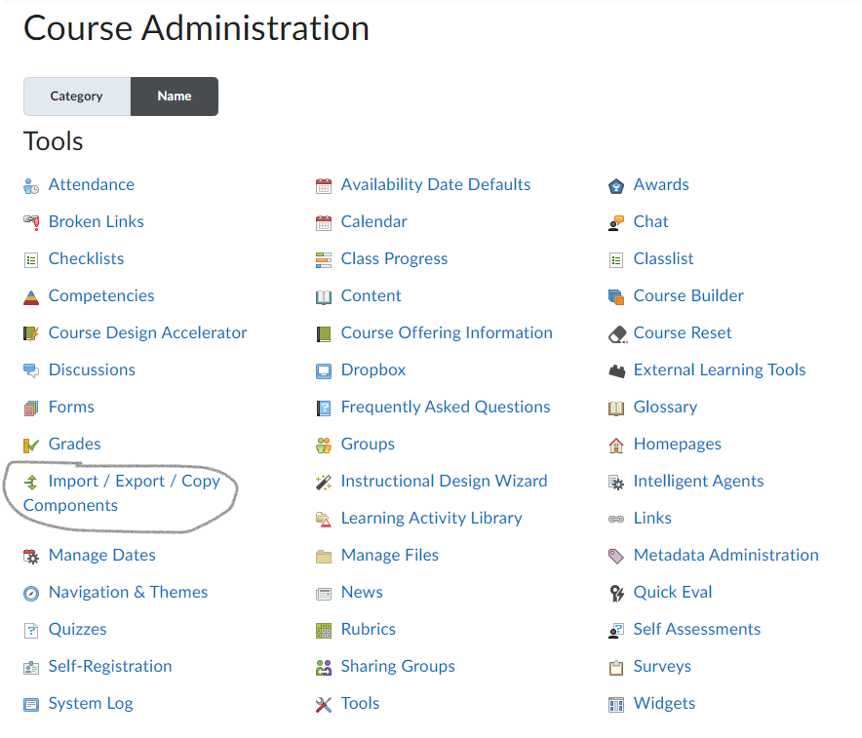
- Select the option to “Import Components” then click on the Start button
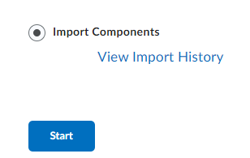
- Use the upload button to locate the .imscc file you unzipped/extracted in step 2, or drag and drop it into the area surrounded by the dotted line .
- It will take some time to upload and convert:
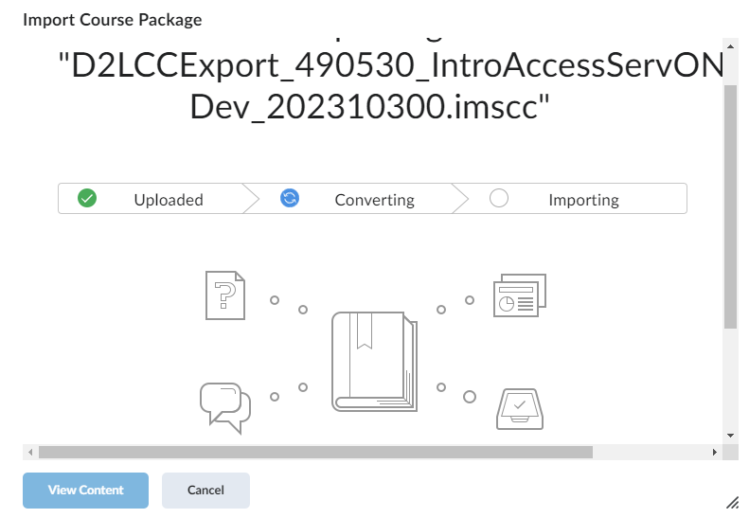
- Once completed, you can click the button to View Content to see the course materials in the Content tool.

In Canvas:
These instructions were taken from https://support.g-w.com/kb/article/73-canvas-how-to-import-a-common-cartridge/
- After logging into Canvas, you will be able to view your Dashboard.
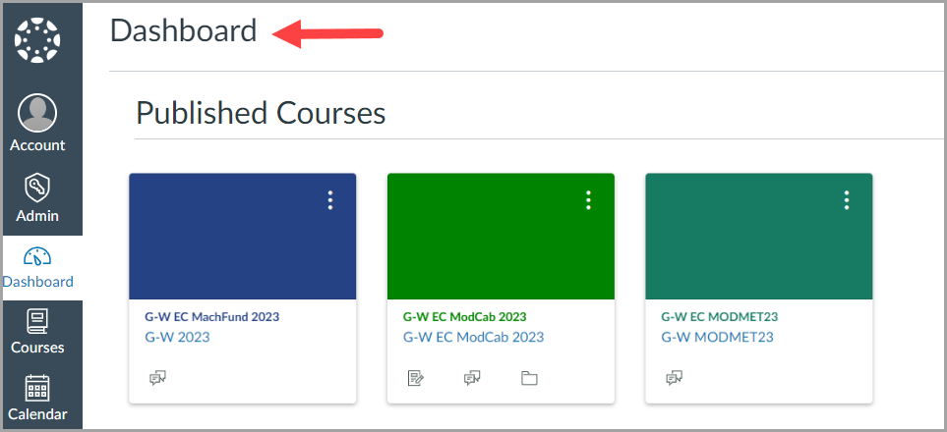
- Create a new course or open a course to which you would like to import content.
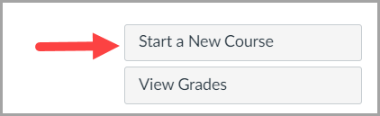
- From the Course Home page, select Settings.
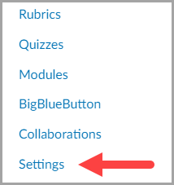
- Select Import Course Content.
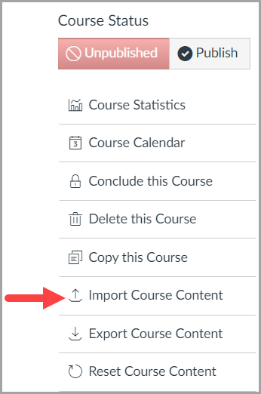
- Next to Content Type, select Common Cartridge 1.x Package.
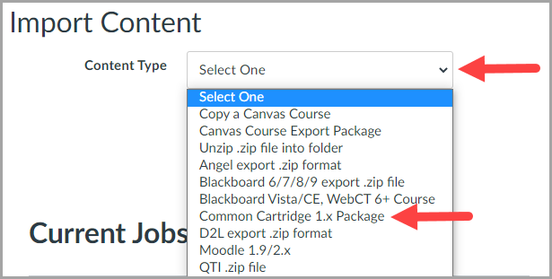
- Select Choose File to upload the common cartridge (.imscc) file that you extracted/unzipped in Step 2. Next to Content, select All content and then select the Import button.
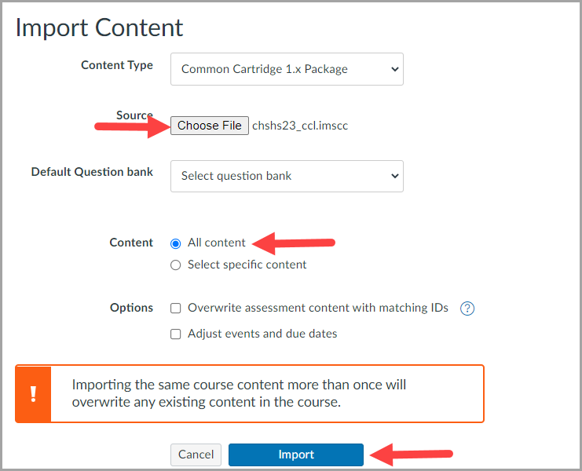
- The cartridge will now begin uploading. Once it is complete, there will be one issue that arises. Do not worry about this issue as this will be fixed once the External App has been configured.
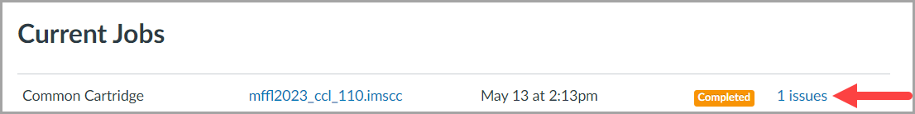
- Select Modules to view the content imported into your course from the common cartridge file.
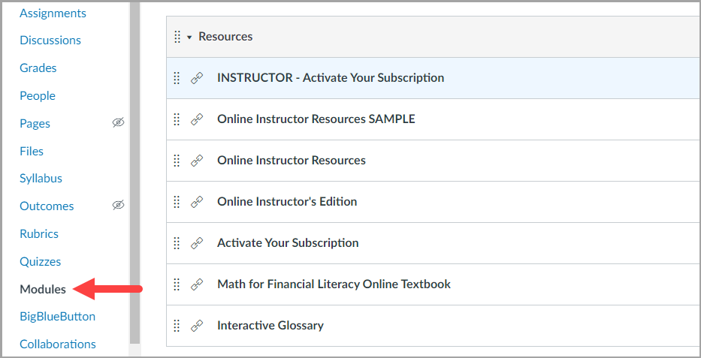

In Blackboard
These instructions were taken from https://employees.senecacollege.ca/spaces/266/blackboard-ultra/articles/setting-up-your-course/16176/importing-a-course-package
- Select Content from the navigation bar.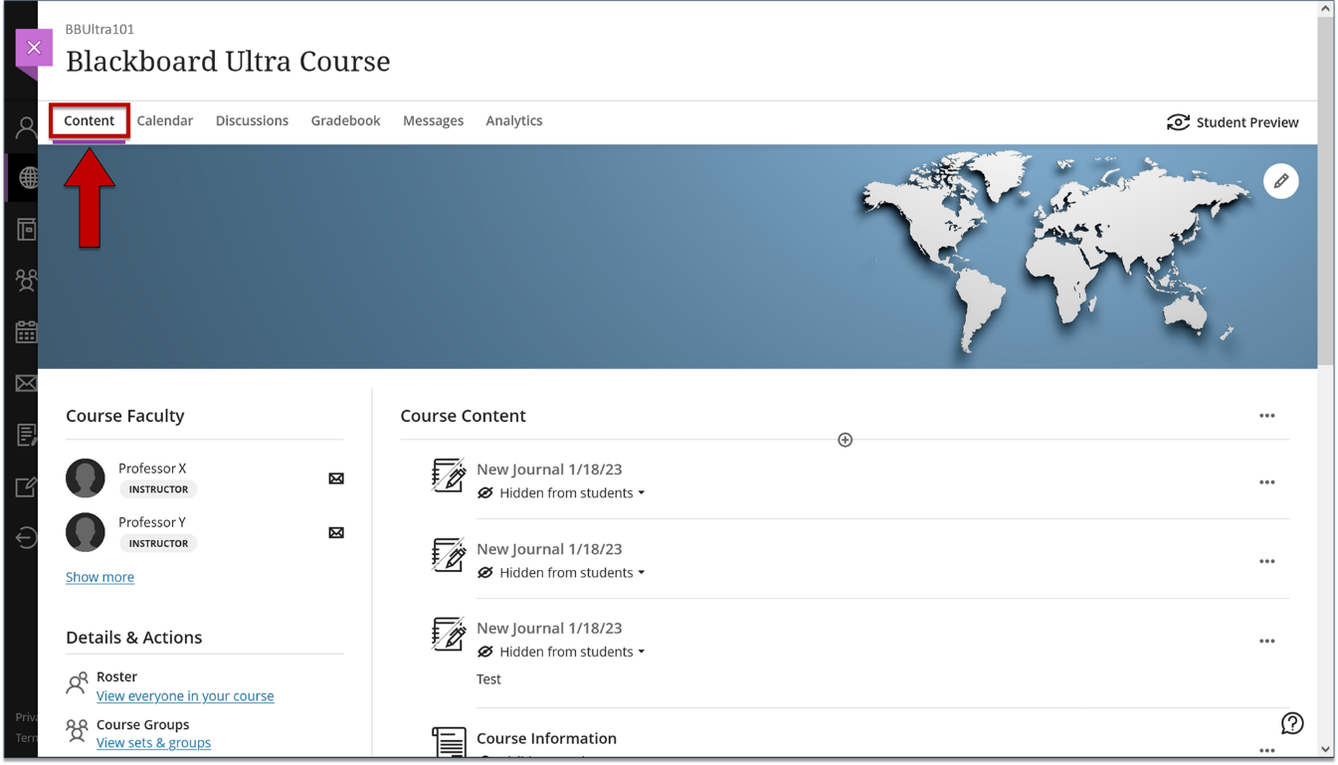
- Select the ellipsis located at the top-right corner. A drop-down menu is displayed.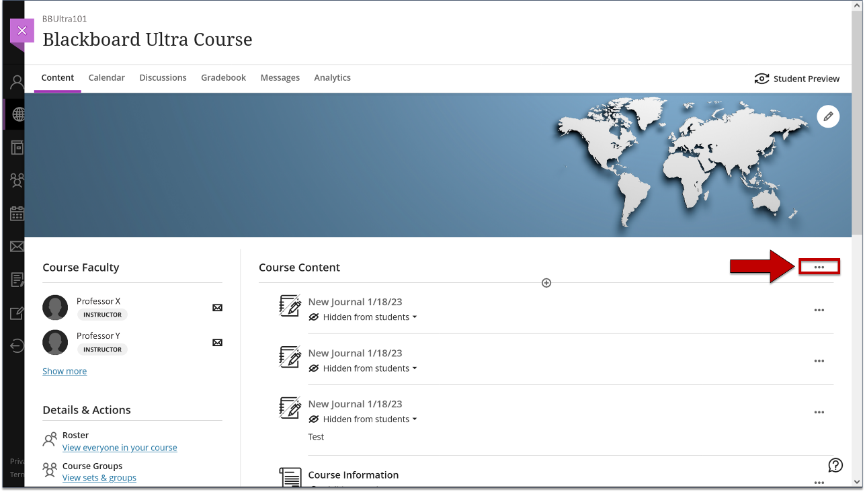
- Select Import Content from the drop-down menu. The Import Content panel is displayed.
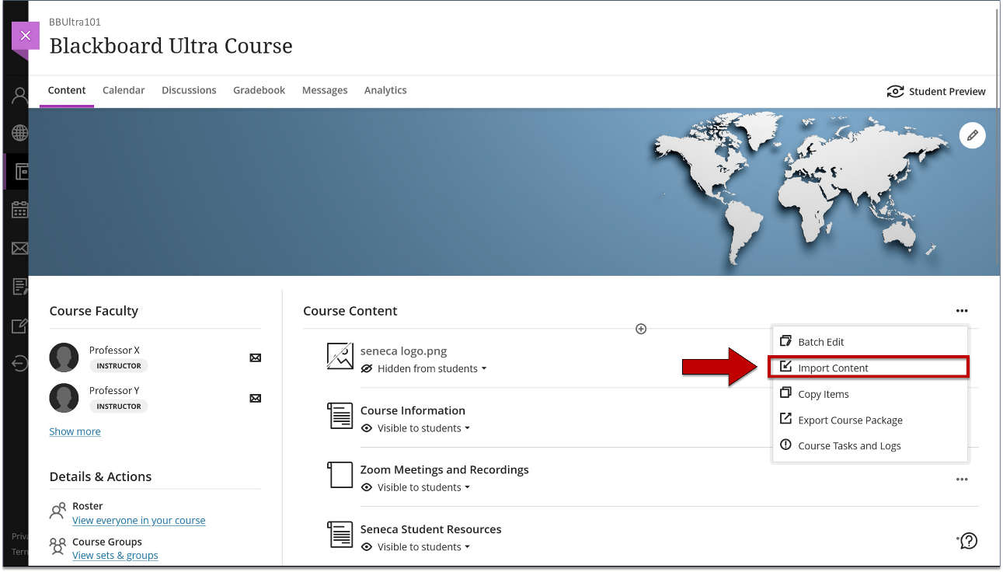
- Select Import Course Content.
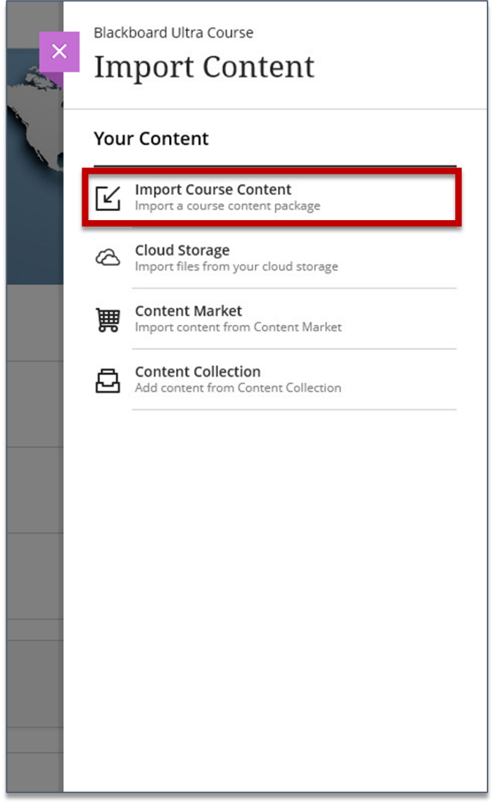
- Select the file you want to import from your computer, and then select Open. Note: It may take a few minutes to import the package. A notification will appear upon a successful/failed import.
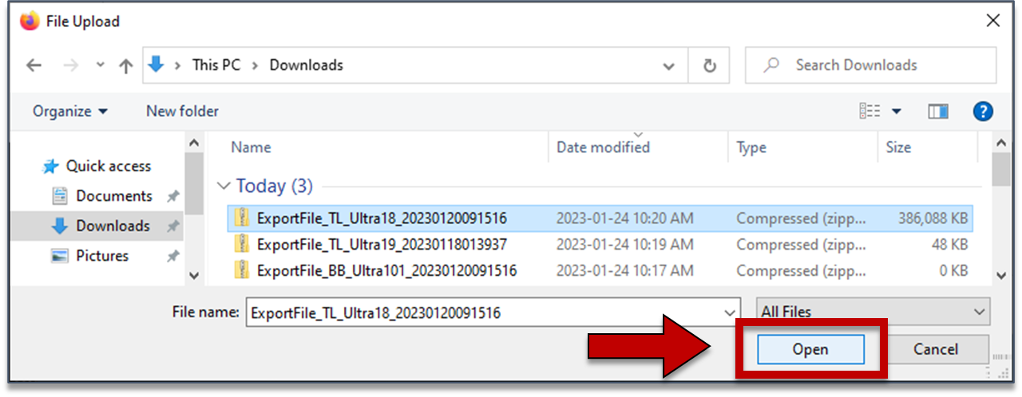

In Moodle (taken from
These instructions were taken from https://willolabs.zendesk.com/hc/en-us/articles/360023452692-Moodle-IMS-Common-Cartridge-Import-Guide
IMS Common Cartridge files can be imported into a Moodle course by utilizing the “Restore” function.
Restoring an IMS Common Cartridge file
- Go to the Moodle course section into which you would like to import the content. In your Moodle left navigation bar, Click on Administration > Restore.
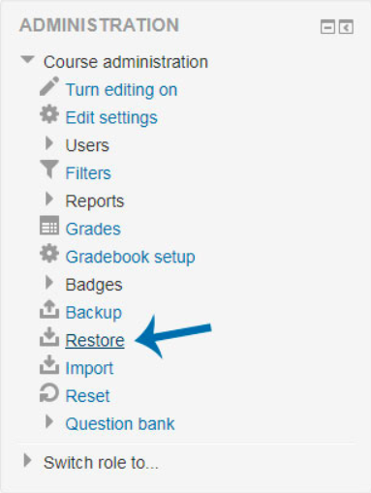
- You will then be prompted to import your backup file. Click “Choose a file” and navigate to your .imscc file or simply drag and drop it into the dialog box. Click "Restore".
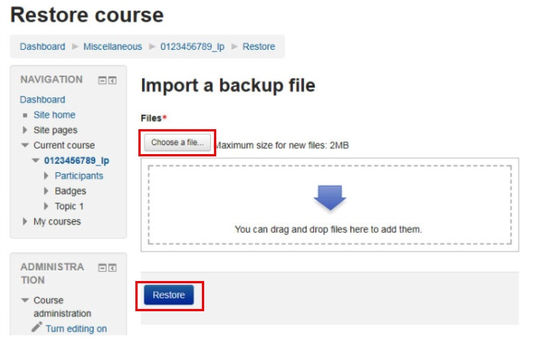
- You are then given a chance to review your Import Settings. You can scroll to the bottom and click “Continue”.
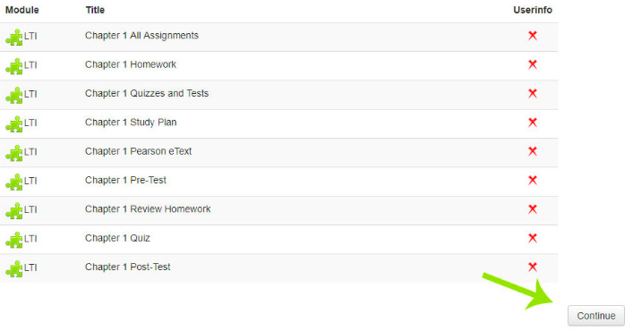Choose if you want to "Merge the backup into this course" for your existing course or "Delete the contents of this course" and then restore. If you are starting with a new shell, this selection does not matter, but if you have a working course, e.g. adding a Syllabus, discussions, etc. then choose "Merge the backup into this course" and Click "Continue".
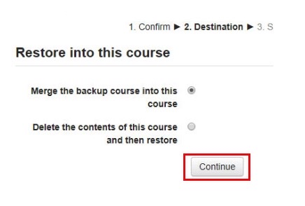
- You can review your settings and verify that only “Include Activities and resources” is selected (with a check mark). Click “Next”.
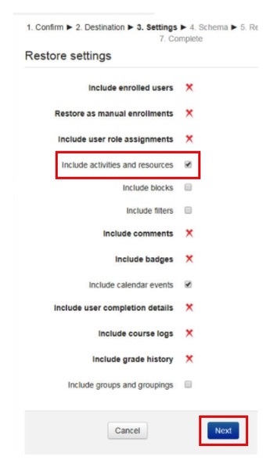
- In the course settings page, confirm your "Course Name", "Course Short Name", "Course start date".
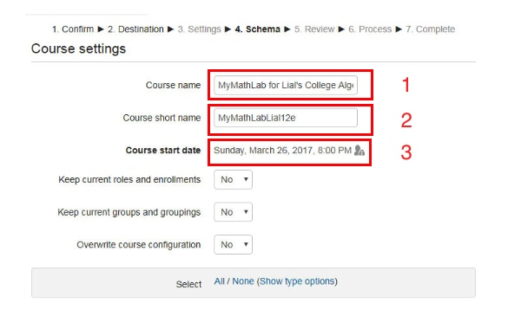When importing links, you are able to select all or select the one's you wish to use for you course by marking the "check box". Click “Next”.
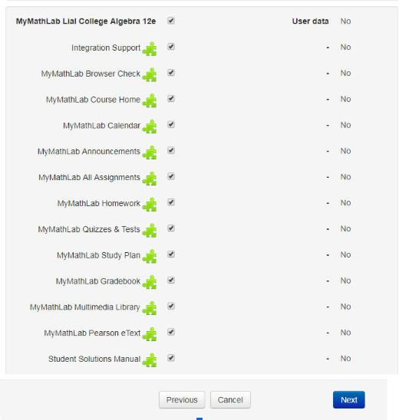
- You can click “Previous” if you need to make changes. Once satisfied with the selections, choose “Perform Restore”.
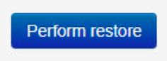
- Once the course is restored successfully, Click "Continue" to start using the course materials.
