Annotated Notetaking: How To

Annotated notetaking is an active learning strategy where you take notes and add your own thoughts, questions, and summaries alongside key information. This helps you process, remember, and apply what you learn.

# How to do it:

1. **Take Organized Notes**: Write down key ideas, concepts, and facts in your own words. Use headings, bullet points, or diagrams if helpful.
2. **Add Annotations:** In the margins or between lines, jot down:
   * + Questions you have
     + Connections to other topics or real-life examples
     + Definitions of tricky words or concepts
     + Summaries of complex ideas in plain language
3. **Highlight or Color-Code:** Use color or symbols to mark:
   * + Important points
     + Areas to review
     + Things you don't understand yet
4. **Review & Reflect:** After class or reading, revisit your notes and annotations to reinforce learning and fill in any gaps.

*The goal is to make your notes interactive not just a record of information, but a tool for deeper understanding.*

# Hard Copy Text Example

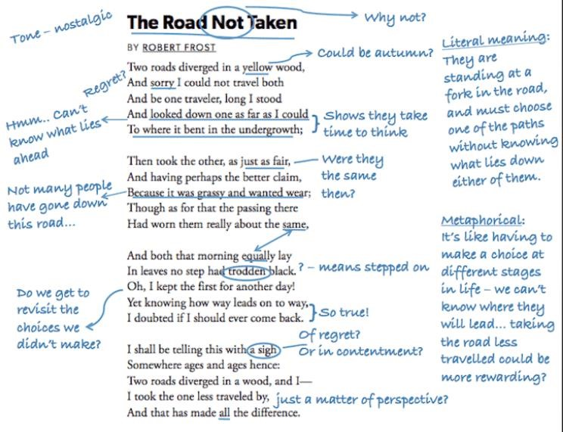

# Digital Text Example

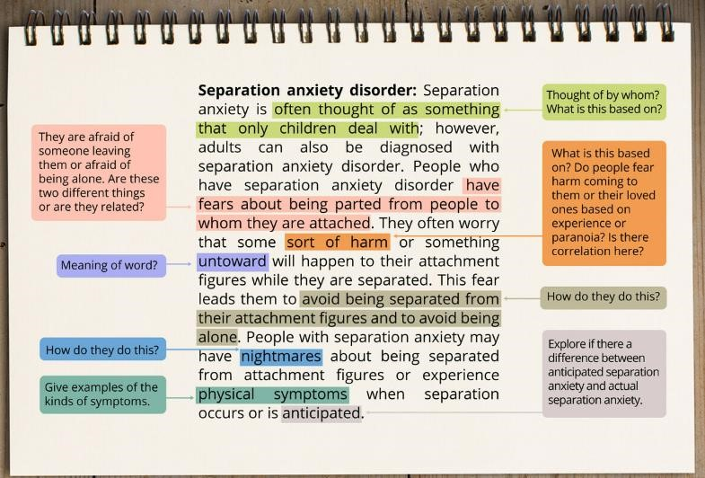

## References:

1. Afflerbach, P., Pearson, P. D., & Paris, S. G. (2008). Clarifying differences between reading skills and reading strategies. *The Reading Teacher, 61*(5), 364–373. https://doi.org/10.1598/RT.61.5.1
2. Dunlosky, J., Rawson, K. A., Marsh, E. J., Nathan, M. J., & Willingham, D. T. (2013). Improving students’ learning with effective learning techniques: Promising directions from cognitive and educational psychology. *Psychological Science in the Public Interest, 14*(1), 4–58. https://doi.org/10.1177/1529100612453266
3. Kiewra, K. A. (1989). A review of notetaking: The encoding-storage paradigm and beyond. *Educational Psychology Review, 1*(2), 147–172. https://doi.org/10.1007/BF01326640
4. McNamara, D. S. (2007). *Reading comprehension strategies: Theories, interventions, and technologies.* Lawrence Erlbaum Associates.
5. Peverly, S. T., & Wolf, C. (2019). Note-taking and memory in different media environments: Principles and applications. *Educational Psychology Review, 31*, 427–454. https://doi.org/10.1007/s10648-019-09489-0