Concept Mapping vs. Mind Mapping

|  |  |  |
| --- | --- | --- |
| Feature | Concept Mapping | Mind Mapping |
| **Structure** | Hierarchical, with cross-links between ideas | Radiating from a central concept, like a web |
| **Purpose** | Analyze relationships between concepts, especially for complex topics | Brainstorm, organize ideas, and visualize connections creatively |
| **Connections** | Labeled arrows with linking phrases  (e.g., *leads to*, *causes*) | Non-labeled branches, focus on keywords |
| **Visual Style** | Boxes/nodes with connectors, logical order | Curved branches, colors, and images |
| **Best Used For** | Research, essay planning, science topics, deep understanding | Planning, studying, creative tasks, note-taking |

# Concept Mapping: Step-by-Step

## Concept Mapping Defined

* Concept mapping is a technique for articulating, organizing, and communicating knowledge.
* Concept maps are hierarchical**:** Concepts are mapped hierarchically, from general to specific, or in a logical order.
* Concept maps help you visualize the hierarchy and relationships between concepts. Use them when trying to make sense of dense material or show how ideas relate.

## Steps:

1. Identify a Focus Question

* Example: *What are the causes and effects of climate change?*

1. List Key Concepts

* Write down important ideas from lectures, readings, or discussions.

1. Organize Concepts Hierarchically

* Place general concepts at the top and more specific ones below.

1. Connect Concepts with Arrows

* Draw lines and write linking phrases like *influences*, *results in*, *is part of*.

1. Add Cross-links

* Identify and draw connections between concepts in different branches to show integrated understanding.

## Best For:

* Understanding complex or abstract ideas (e.g., systems, theories, processes)
* Science, social studies, philosophy
* Essay outlines

## Example Concept Map

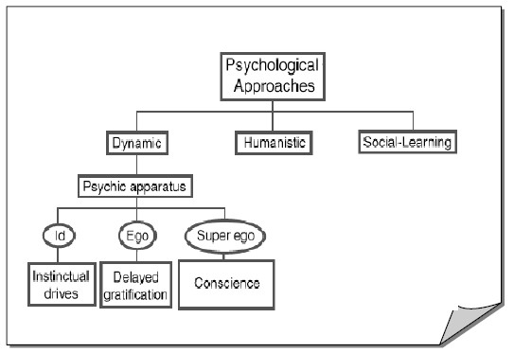

# Mind Mapping: Step-by-Step

## Mind Maps Defined

• Mind maps are creative, nonlinear tools that help you visualize and connect ideas around one topic. Use them to brainstorm, plan, and study. It uses a diagram with branches, keywords, images, and colors to connect related ideas and concepts, mirroring how the brain processes information. This technique helps to brainstorm, organize thoughts, retain and recall information more effectively.

## Steps:

1. Write the Central Topic in the Middle

* **Example:** *Study Skills*

1. Add Main Branches Around the Topic

* ***Example****:* *Time Management*, *Memory*, N*otetaking*

1. Expand with Sub-branches

* *Each main branch gets smaller branches with details.*

1. Use Color, Icons, and Drawings

* *Helps boost memory and creativity.*

1. Keep it Concise

* *Use 1–2 keywords per branch.*

## Best For:

* Brainstorming essays or projects
* Preparing for exams
* Creative tasks or problem solving
* Summarizing chapters

## How to use a Mind Map for memory

* Visualize the map without looking
* Re-draw sections from your memory
* Always double check your mind map after recalling information

## Video Link

• [Benefits of Mind mapping](https://youtu.be/OGKhrfDFyzY)

## Example Mind Map

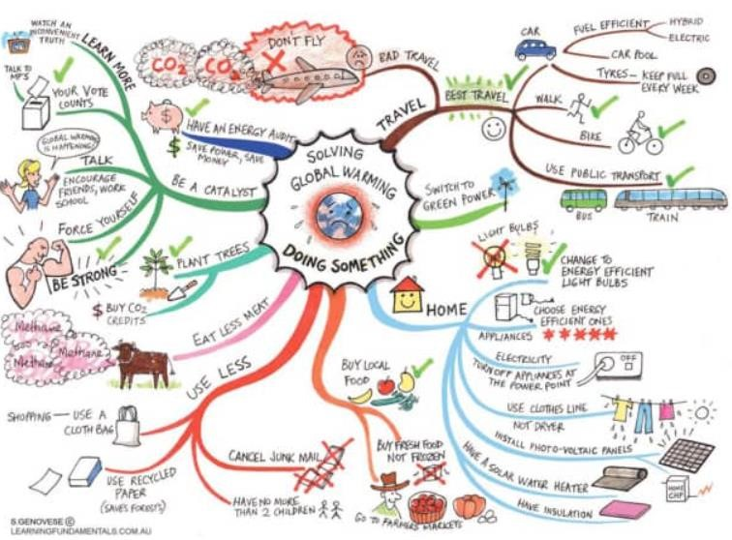

# When to Use Each

|  |  |
| --- | --- |
| Use Concept Maps When... | Use Mind Maps When... |
| You’re analyzing relationships | You’re brainstorming or organizing ideas |
| Studying subjects with layered complexity | You want a quick overview of a topic |
| You need to show cause-effect relationships | You want to be creative or visual |
| Writing analytical or research-based work | You’re making revision notes |

## References

* Buzan, T. (2018). *The mind map book: Unlock your creativity, boost your memory, change your life* (2nd ed.). BBC Active.
* Davies, M. (2011). Concept mapping, mind mapping and argument mapping: What are the differences and do they matter? *Higher Education, 62*(3), 279–301. https://doi.org/10.1007/s10734-010-9387-6
* Eppler, M. J. (2006). A comparison between concept maps, mind maps, conceptual diagrams, and visual metaphors as complementary tools for knowledge construction and sharing. *Information Visualization, 5*(3), 202–210. https://doi.org/10.1057/palgrave.ivs.9500131
* Farrand, P., Hussain, F., & Hennessy, E. (2002). The efficacy of the ‘mind map’ study technique. *Medical Education, 36*(5), 426–431. https://doi.org/10.1046/j.1365-2923.2002.01205.x
* Novak, J. D., & Cañas, A. J. (2008). The theory underlying concept maps and how to construct and use them. *Institute for Human and Machine Cognition.* https://cmap.ihmc.us/docs/theory-of-concept-maps
* Vanides, J., Yin, Y., Tomita, M., & Ruiz-Primo, M. A. (2005). Using concept maps in the science classroom. *Science Scope, 28*(8), 27–31.