

**How to Build a Macro Schedule**

A macro schedule helps you stay on top of your workload by giving you a clear overview of the entire term. It’s your big-picture game plan.

**Step 1:** Start by mapping out all your important deadlines—assignments, tests, projects—on a calendar or planner.

**Step 2:** Set phone reminders: one a week before (a “soft deadline” to start prepping) and another three days before it's due.

**Step 3:** Break down your bigger deadlines into smaller weekly and daily to-dos. This microplanning makes it easier to stay on track and avoid last-minute stress.

By working backward from your due dates and staying consistent, you’ll build better habits and reduce academic anxiety.

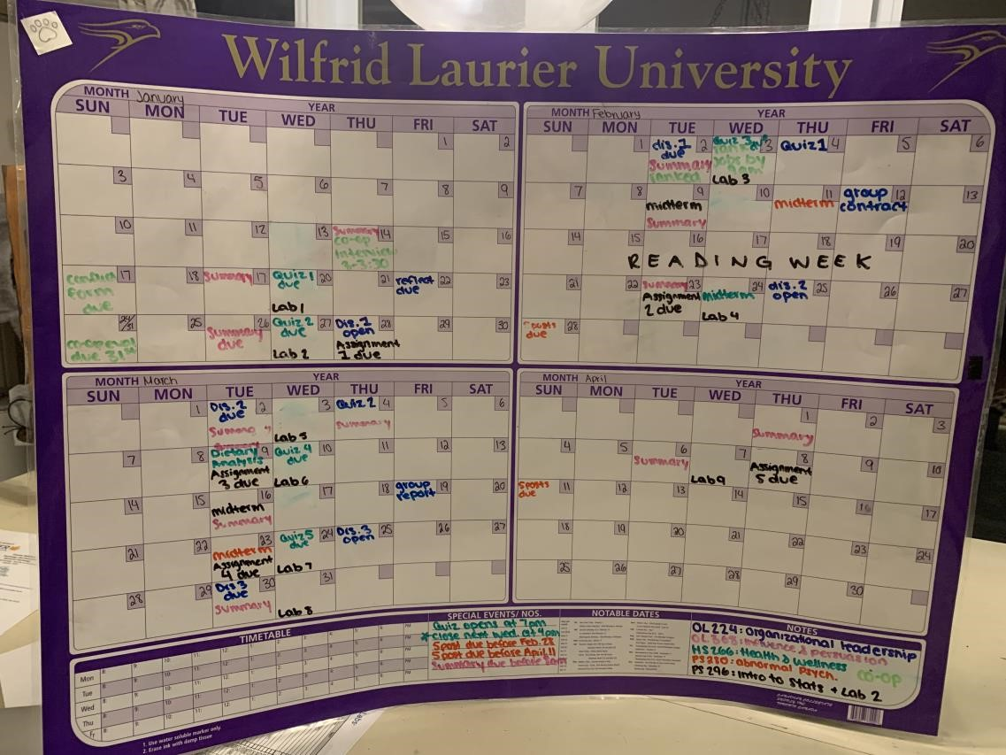

Last Updated: 2025