Using Mind Maps for Essays and Boosting Memory

## What is a Mind Map?

A mind map is a visual tool that organizes information around a central concept or key idea. From this central point, related ideas branch out in various directions, much like the structure of a tree. The main idea forms the "trunk," while connected thoughts grow outward as "branches" and smaller "twigs," representing sub-points or details.

## How Can Mind Maps Be Used?

Mind maps are flexible tools that can support many academic and personal tasks, such as:

* Taking notes and summarizing key information
* Solving problems or exploring solutions
* Brainstorming and developing new ideas
* Outlining essays, assignments, or presentations
* Supporting study sessions and enhancing memory recall

## How Do Mind Maps Support Studying and Memory?

Mind maps help learners break down and organize complex information by highlighting key words, ideas, and core concepts. Because they eliminate the need for full sentences, mind maps support faster information processing and make it easier to see how ideas are connected. This makes them useful for both essay planning and when studying for exams. By engaging multiple learning pathways visual, verbal, and written, mind maps can also improve long-term memory retention.

# Tips for Creating a Mind Map

## What You’ll Need:

* A blank sheet of paper or digital tool
* Pens, pencils, or markers

### Steps:

1. **Start with the Central Idea:** Write the main concept in the middle of the page. Make it stand out by using colours, images, bold letters, or shapes. This visual emphasis will help you remember the core idea.

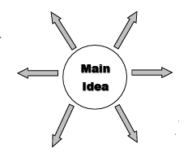

1. **Add First-Level Ideas:** Draw lines outward from the center and note down key words or images related to your main idea at the end of each line.
2. **Include Sub-Ideas:** From each first-level idea, branch out further by adding supporting details or examples.

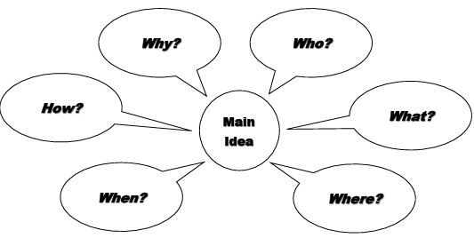

1. **Expand as Needed:** Keep adding new branches or return to the center to create new main branches. This allows you to capture all relevant information while staying organized.

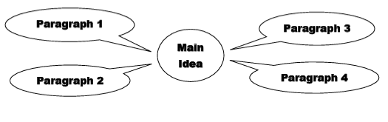

1. **Customize It:** Make your mind map as creative and personalized as you like. Use colours, symbols, pictures, or even digital tools or apps to suit your learning style.

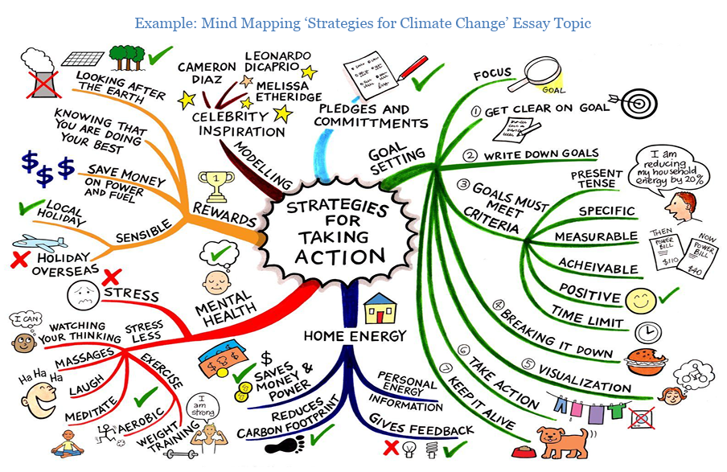

Mind maps can be created using traditional materials like paper and markers, or digitally through various software programs or mobile apps designed for mind mapping.

## Final Thoughts

By visually arranging information, mind maps help clarify connections, reinforce memory, and simplify complex topics, making them a valuable strategy for academic success.

### References

* Buzan, T. (n.d.). *Mind maps and how to use them*. StudyLib. <https://studylib.net/doc/8739681/mind-maps-and-how-to-use-them>
* Hay, A. (2024). *From chaos to clarity: Using mind maps to navigate adult ADHD*. *ResearchGate*. <https://www.researchgate.net/publication/384940151_From_Chaos_to_Clarity_Using_Mind_Maps_to_Navigate_Adult_ADHD>
* University of Adelaide Writing Centre. (2014). *Mind mapping: Writing Centre learning guide* [PDF]. The University of Adelaide. <https://www.adelaide.edu.au/writingcentre/sites/default/files/docs/learningguide-mindmapping.pdf>