**Notetaking & the Study Cycle**

Lectures are a cornerstone of university learning, delivering key concepts in real time—no pause or rewind. To stay attentive and retain material, it’s essential to use strategies *before*, *during*, and *after* lectures.

## Before the Lecture

* **Preview the material** by reading assigned chapters or working through problems to prime your understanding and link new ideas to prior knowledge
* **Check the syllabus or lecture outline** to understand the focus and goals for the session.
* **Quickly review previous notes** (5–10 minutes) to reinforce continuity across lectures.
* **Prepare questions** in advance—this creates a purposeful focus and engagement during class
* **Ready your tech** for online classes: test your connection and close distracting tabs.

## During the Lecture

* **Choose a distraction-free spot:** Sit front and center in person or find a quiet space online away from your phone.
* **Take focused and organized notes:** Use bullet points, shorthand, and symbols (e.g., →, ≠, $, ~) to record crucial ideas.
* **Watch for verbal and visual cues** like emphasis, repetition, or board highlights—these often signal key insights.

## After the Lecture

* **Review notes within 24 hours:** Summarize in your own words, connect with pre-lecture materials, and clarify any gaps.
* **Turn notes into active study tools:** Generate self-test questions or flashcards to boost long-term memory through retrieval practice.
* **Build a study guide** by integrating lecture content with textbook readings, pulling out themes, terms, and concept maps. (Check out our “Studying for Exams” tab for information on study guides).

By systematically following these steps—**Preview → Engage → Review/Practice**—you’re not just attending class; you’re building a durable foundation for understanding, recall, and academic success.

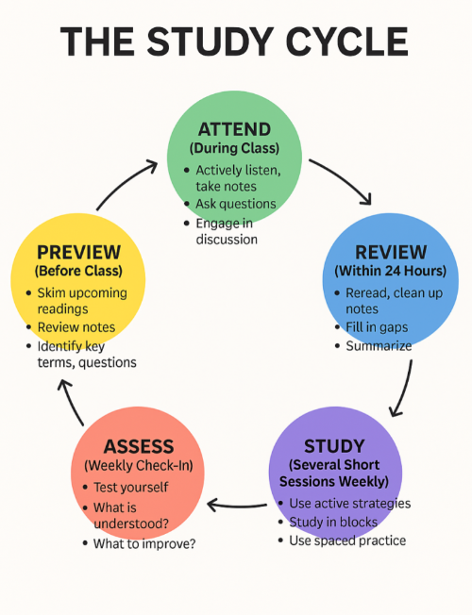

### References:

* Roediger, H. L., & Karpicke, J. D. (2006). Test‑enhanced learning: Taking memory tests improves long‑term retention. *Psychological Science, 17*(3), 249–255. This foundational study highlights the benefits of retrieval practice as a powerful tool for memory.
* Cepeda, N. J., Pashler, H., Vul, E., Wixted, J. T., & Rohrer, D. (2006). Distributed practice in verbal recall tasks: A review and quantitative synthesis. *Psychological Bulletin, 132*(3), 354–380. Demonstrates that spacing out study sessions enhances long-term retention.
* Szpunar, K. K., Khan, N. Y., & Schacter, D. L. (2013). Interpolated memory tests reduce mind wandering and improve learning of online lectures. *PNAS, 110*(15), 6313–6317. Shows that retrieval breaks during video lectures improve focus and learning.
* Savoy, A., Proctor, R. W., & Salvendy, G. (2009). Information retention from PowerPoint™ and traditional lectures. *Computers & Education, 52*(4), 858–867. Compares formats and emphasizes the importance of active engagement in lecture design.
* Griffiths, P., & Cook, E. (2022). Using the study cycle model to support better student learning: A faculty guide. *Advances in Physiology Education*. Summarizes practical implementation of preview–engage–review for instructors.