Study Guide 

# The Purpose of a Study Guide

A study guide helps you organize your lecture notes and textbook readings to improve both your understanding and retention of large amounts of material. Creating study guides that use visual elements can be especially helpful, as visual organization allows you to identify related ideas and form meaningful connections, which supports the deeper levels of learning many instructors expect.

# Study Guides

Effective test preparation goes beyond simply memorizing facts, figures, formulas, or definitions. Many professors look for evidence of critical thinking on exams, which requires more than just rote learning. To build this skill, it's important to actively organize and engage with the course content. Aim to create study guides on a weekly basis throughout the term. About two to three weeks before your exam, design a practice test that mirrors the length and format of the actual exam and use it to quiz yourself. Consider starting each study session with a new practice test. As you prepare, think about the variety of question types you might encounter.

# Examples of Learning Levels (Types of Questions)

Take a look at the sample questions below, drawn from a sociology course. The first question focuses on basic recall—something you can master using memorization strategies like flashcards. The other questions challenge you to analyze information, compare ideas, and apply your knowledge to new situations. These types of questions often go beyond what is directly covered in lectures or textbooks.

# Sample Questions:

Question 1:  
 Which of the following best describes a group of relatives joined through marriage?  
 a) conjugal family  
 b) extended family  
 c) nuclear family  
 d) none of the above

Question 2:  
 Explain the similarities and differences among matriarchal, neolocal, and patriarchal societies.

Question 3:  
 Using an example, describe how the economy operates and the roles individuals hold within a neolocal society.

# Start By:

• **condensing** course material into smaller amounts of information that are easier to remember.

• **Visualizing**, understand, and demonstrate relationships among concepts and ideas.

• **creating** examples and apply information to "real world" situations.

# Think in Pictures, Colours, and Shapes:

Visuals are often easier to remember than abstract ideas, which is why your instructors and textbooks frequently use images to support learning. Try engaging in “colorful thinking” by creating your own mental images to connect with academic material. When taking notes in class or from readings, use color to emphasize headings and key concepts. Shapes, such as triangles, boxes, flowcharts, and circles can help you visually organize and group ideas in meaningful ways..

# Concept map and branching diagram

Many learners find it helpful when information is presented visually rather than just as text. Concept maps and branching diagrams are effective tools for organizing material in a spatial format instead of a traditional linear outline. These tools still follow a general-to-specific structure but allow you to add supporting details, examples, and connections. Concept maps and diagrams can be useful for organizing information in any subject area, helping you to better understand and apply what you’re learning.

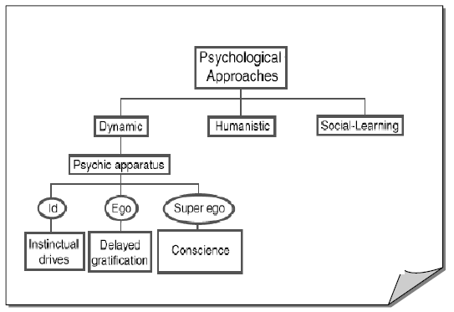

# Mind Maps

## What is a Mind Map?

A mind map is a visual diagram that helps you organize words, concepts, and ideas by showing how they relate to a central theme or keyword. You can think of a mind map like a tree: the main idea is the trunk, and the supporting ideas branch out from it. These branches can grow into smaller ideas—like twigs—that connect back to the larger concepts.

## How Do Mind Maps Help with Studying and Improving Memory?

Mind maps help you study by turning class notes and complex theories into simple, visual summaries using key words and short phrases. Since mind maps focus on quick idea capture rather than full sentences, they make it easier for your brain to process and recall information. This method reduces information overload and allows for faster, more effective review when preparing for exams.

Diagram of mind map with colours, images and words

# Comparison chart

A comparison chart allows you to organize information visually so that you can see relationships among categories or characteristics. It is a very effective format when you need to be able to understand the differences or similarities among facts, theories, theorists, processes, etc. Focus on being able to identify the differences. Try drawing the chart from memory and follow uping with a verbal explanation.

|  |  |  |  |
| --- | --- | --- | --- |
|  | Transmission | Vaccine | Symptoms |
| Hepatitis A |  |  |  |
| Hepatitis B |  |  |  |
| Hepatitis C |  |  |  |

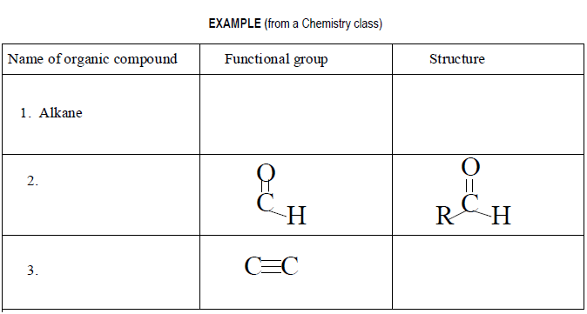

# Concept card/ Flash Cards

On the front of the card you will write the question, on the back the answer. When answering the flashcard answer these additional questions too.

1. Answer
2. Who?
3. What?
4. Where?
5. Why?
6. When?
7. How?
8. Provide own example

### Example Flash Card

**Front -**Digestive System (Stomach)

**Back**

1. Gastric Juices
2. Who does this happen to?
3. What is happening?
4. Where does it happen?
5. When does it happen?
6. Why does it happen?
7. How does it happen?
8. Provide example

# Diagram Labeling

Diagrams are powerful tools for visually representing information that involves movement, sequences, or stages. They can help you break down and understand processes, procedures, and step-by-step systems. For instance, in a geology course, you might draw a diagram to show how layers of rock are created over time. In a political science class, a diagram can illustrate the steps involved in turning a bill into law. Diagrams make complex information clearer and easier to remember.

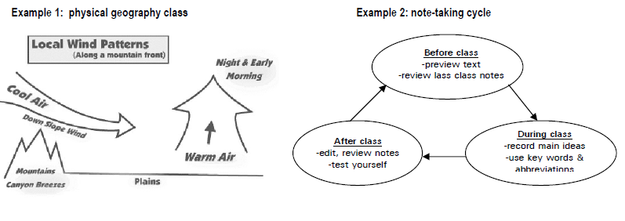

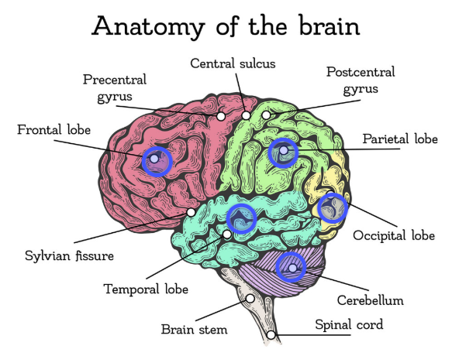

# Timelines

Timelines help you arrange information in the order that events or developments occurred. They are useful for reviewing material that needs to be understood as a sequence or progression. Timelines can be especially helpful in courses where chronological order is important, such as:

* **Historical events:** history, anthropology, political science, music, art
* **Biological processes:** biology, anatomy, physiology
* **Developmental stages:** psychology, biology, environmental studies

By using a timeline, you can see how ideas, events, or processes unfold over time, making it easier to grasp cause-and-effect relationships and remember key details.

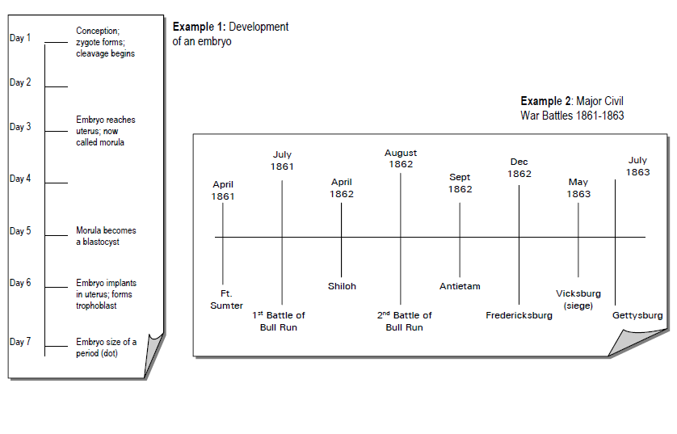

# Mnemonics:

* Mnemonics are memory tools that help you create mental connections, making it easier to remember important information. When used wisely, mnemonics can be a powerful study strategy just be careful not to rely on them too much, as true understanding of the material is still essential. Mnemonics are most effective when used selectively to help you recall key facts, sequences, or lists for exams.
* There are many types of mnemonics, and you’ve probably already used some without realizing it. Here are a few popular examples:
* **Acronyms:** These combine the first letters of words into a short, memorable word. In math, for example, **BEDMAS** helps you remember the order of operations: **Brackets, Exponents, Division, Multiplication, Addition, Subtraction**.
* **Rhymes:** Short, catchy phrases can stick in your mind. Psychology students might use “**Id is the kid!**” to remember Freud’s theory of the impulsive, childlike id.
* **Sentences or Phrases:** Creating a memorable sentence using the first letters of a series of words can help you recall lists. For geography, **Never Eat Shredded Wheat** helps you remember the cardinal directions: **North, East, South, West**. In biology, students use **Kings Play Chess On Frosted Glass Surfaces** to recall the taxonomic classification: **Kingdom, Phylum, Class, Order, Family, Genus, Species**.
* **Acronyms in Other Subjects:** In trigonometry, **SOHCAHTOA** helps recall sine, cosine, and tangent ratios. In French, **DR & MRS VANDERTRAMPP** lists verbs that use **être** as their auxiliary in the passé composé.

These are just a few of the many types of mnemonics that you can use. As you study for your tests, use your imagination to generate fitting mnemonics for some of the key information in your courses.

# Repetition

* The more frequently you review information, the stronger your memory of it becomes. To make your study sessions even more effective, try not to repeat the exact same activity each time. Instead, switch up your methods—this variety helps you build multiple pathways in your long-term memory. For example, you might read your notes one day, quiz yourself the next, and create a diagram or teach the concept to someone else after that. Using different approaches keeps your mind engaged and strengthens retention.

## References

1. Dunlosky, J., Rawson, K. A., Marsh, E. J., Nathan, M. J., & Willingham, D. T. (2013). Improving students’ learning with effective learning techniques: Promising directions from cognitive and educational psychology. *Psychological Science in the Public Interest*, 14(1), 4–58. <https://doi.org/10.1177/1529100612453266>
2. Fiorella, L., & Mayer, R. E. (2016). Eight ways to promote generative learning. *Educational Psychology Review*, 28(4), 717–741. <https://doi.org/10.1007/s10648-015-9348-9>
3. Hattie, J., & Yates, G. C. R. (2013). *Visible learning and the science of how we learn*. Routledge.
4. Novak, J. D., & Cañas, A. J. (2008). The theory underlying concept maps and how to construct them. *Institute for Human and Machine Cognition*. <https://cmap.ihmc.us/docs/theory-of-concept-maps>
5. Weinstein, Y., Madan, C. R., & Sumeracki, M. A. (2018). Teaching the science of learning. *Cognitive Research: Principles and Implications*, 3(2). <https://doi.org/10.1186/s41235-017-0087-y>

Last Updated: 2025