Laurier Course Registration Quick Reference Guide

# Preparing for Course Registration

Please start by filling out this box with your registration information:

My Course Registration Date: ___________________________

My Course Registration Time: ___________________________

My Program (ex. BBA/BA/BSc/BSW): ________________________

My Major: _____________________________________

Check your **Program Requirements** in the [Course Registration Guide](https://students.wlu.ca/registration-and-finances/registration-guide/index.html) then complete the table below.

Follow these next steps to prepare for course registration:

1. List your [Required Courses](https://students.wlu.ca/registration-and-finances/registration-guide/step-1-program-requirements/index.html?ref=registration-and-finances%2Fregistration-guide%2Fstep-1-program-requirements%2Ffirst-year-program-requirements.html) in the Courses column. These are found in Step 1: Program Requirements in the Course Registration Guide.
2. List potential [Elective Courses](https://students.wlu.ca/registration-and-finances/registration-guide/step-2-choose-electives/index.html?ref=registration-and-finances%2Fregistration-guide%2Fstep-1-program-requirements%2Ffirst-year-course-offerings.html) in the Courses column. These are found in Step 2: Choose Electives in the Course Registration Guide.
3. Go to [Browse Classes](https://loris.wlu.ca/register/ssb/term/termSelection?mode=search) on loris.wlu.ca to confirm which term(s) each course is offered (fall/winter/spring). After you select your term, you can complete an Advanced Search to select your campus and level.
4. View **registration restrictions** for each course. In Browse Classes, click the course title to view Class Details. Take note of the campus, restrictions and any grade 12 and university prerequisites.

|  |  |  |  |  |
| --- | --- | --- | --- | --- |
| **Courses** | **Term Offered** | **Restrictions** | **Prerequisites** | **Required Lab or Tutorial?** |
| Ex: CH110 | Fall | None | 4U (Grade 12) Chem | Lab |
| Ex: CH111 | Winter | None | CH110 | Lab |

|  |  |  |  |  |
| --- | --- | --- | --- | --- |
| **Courses** | **Term Offered** | **Restrictions** | **Prerequisites** | **Required Lab or Tutorial?** |
|  |  |  |  |  |
|  |  |  |  |  |
|  |  |  |  |  |
|  |  |  |  |  |
|  |  |  |  |  |
|  |  |  |  |  |
|  |  |  |  |  |
|  |  |  |  |  |
|  |  |  |  |  |
|  |  |  |  |  |

1. Use [Visual Schedule Builder](http://scheduleme.wlu.ca/vsb/) to view potential schedule options. Don’t forget about your personal obligations and scheduling preferences when considering timetable options (morning vs. evening classes, commuting, work, family commitments, etc.) This step may take many tries but it’s worth the effort to find a schedule that will set you up for a successful first year!
2. Once you have found the schedule you are happy with, record the CRNs (course reference number) for each unique course/lab/tutorial you want to take.

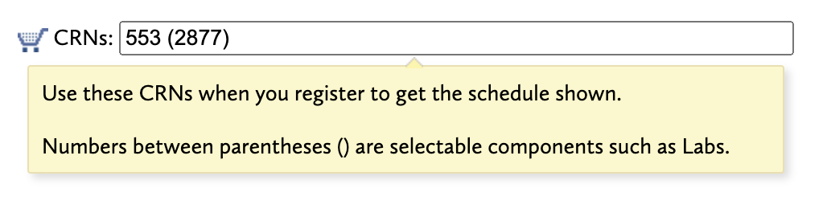

**Note:** First-year students can take a maximum of 2.5 credits per term (typically 5 courses), unless your program states otherwise.

# Term 1 Planner:

|  |  |  |  |
| --- | --- | --- | --- |
| **Course and Section** | **Course CRN** | **Lab/ Tutorial and**  **Section** | **Lab/ Tutorial CRN** |
| Ex: CH110 Lecture A | 1111 | CH110 Lab 1 | 2222 |
|  |  |  |  |
|  |  |  |  |
|  |  |  |  |
|  |  |  |  |
|  |  |  |  |
|  |  |  |  |
|  |  |  |  |
|  |  |  |  |
|  |  |  |  |

# Term 2 Planner:

|  |  |  |  |
| --- | --- | --- | --- |
| **Course and Section** | **Course CRN** | **Lab/ Tutorial and**  **Section** | **Lab/ Tutorial CRN** |
| Ex: CH111Lecture B | 3333 | CH111 Lab 1 | 4444 |
|  |  |  |  |
|  |  |  |  |
|  |  |  |  |
|  |  |  |  |
|  |  |  |  |
|  |  |  |  |
|  |  |  |  |
|  |  |  |  |

# Step-by-step Course Registration

## Sign into LORIS:

* + Go to loris.wlu.ca.
  + Your network login username is the first 4 letters of last name and last 4 numbers of student number (example: smit1234).

## Navigate to Registration Page:

* + Click on Student Services.
  + Click on Registration.
  + Go to “Register for Classes”.
  + Select your Term and click “Continue”.

## Add courses using CRNs:

* + Select the “Enter CRNs” tab.
  + Type each CRN into a box (example: 1636). CRNs can be found in in [Visual](https://scheduleme.wlu.ca/) [Schedule Builder](https://scheduleme.wlu.ca/) or [Browse Classes](https://loris.wlu.ca/register/ssb/registration).
  + Click “Add Another CRN” until you have enough boxes for all courses, labs, and tutorials in your whole term.
  + When finished adding CRNs, click “Add to Summary”.
  + Press “Submit” on the summary page to officially register in the course(s).

**Note:** Remember that labs and tutorials will have their own CRN. You must add the course CRN and lab/tutorial CRN at the same time in order to successfully register for the course.

## Ensure registration was successful

* + To be successfully registered in your courses, you should see “Registered” beside each lecture and lab or tutorial.
  + Go to “Schedule and Options” to view your weekly schedule.

**Note:** Only synchronous courses will appear in your schedule. Since virtual asynchronous classes do not have an assigned time, they will not appear in the schedule.

**Registration Tips**

* **Plan out your schedule** before you register using [Visual Schedule Builder](https://scheduleme.wlu.ca/) and [Browse Classes](https://loris.wlu.ca/register/ssb/registration).
* **It’s ok to schedule two classes back-to-back**. 10 minutes between classes is enough time to get across campus.
* If an elective you want to take is full **put your name on the waitlist** and register in an alternate elective. Note that not all courses offer a waitlist.
* Use the email icon in the “Schedule and Options” tab to **email yourself a copy** of your schedule.

For further course registration assistance, check out the Course Registration Guide.